**Leaf Pick up**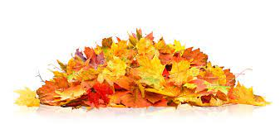

The Town offers a leaf pickup for Town residents in the fall. The pick up starts the first week in November.

**Leaves only, no brush or sticks**

**For all other rubbish please obtain a compost permit at the Town Clerks office!**

You can rake leaves to the curb OR put them in clear plastic bags

**DO NOT put them out more than 2 days before pick up is scheduled or the leaves can blow causing drainage issues or more work for you!**