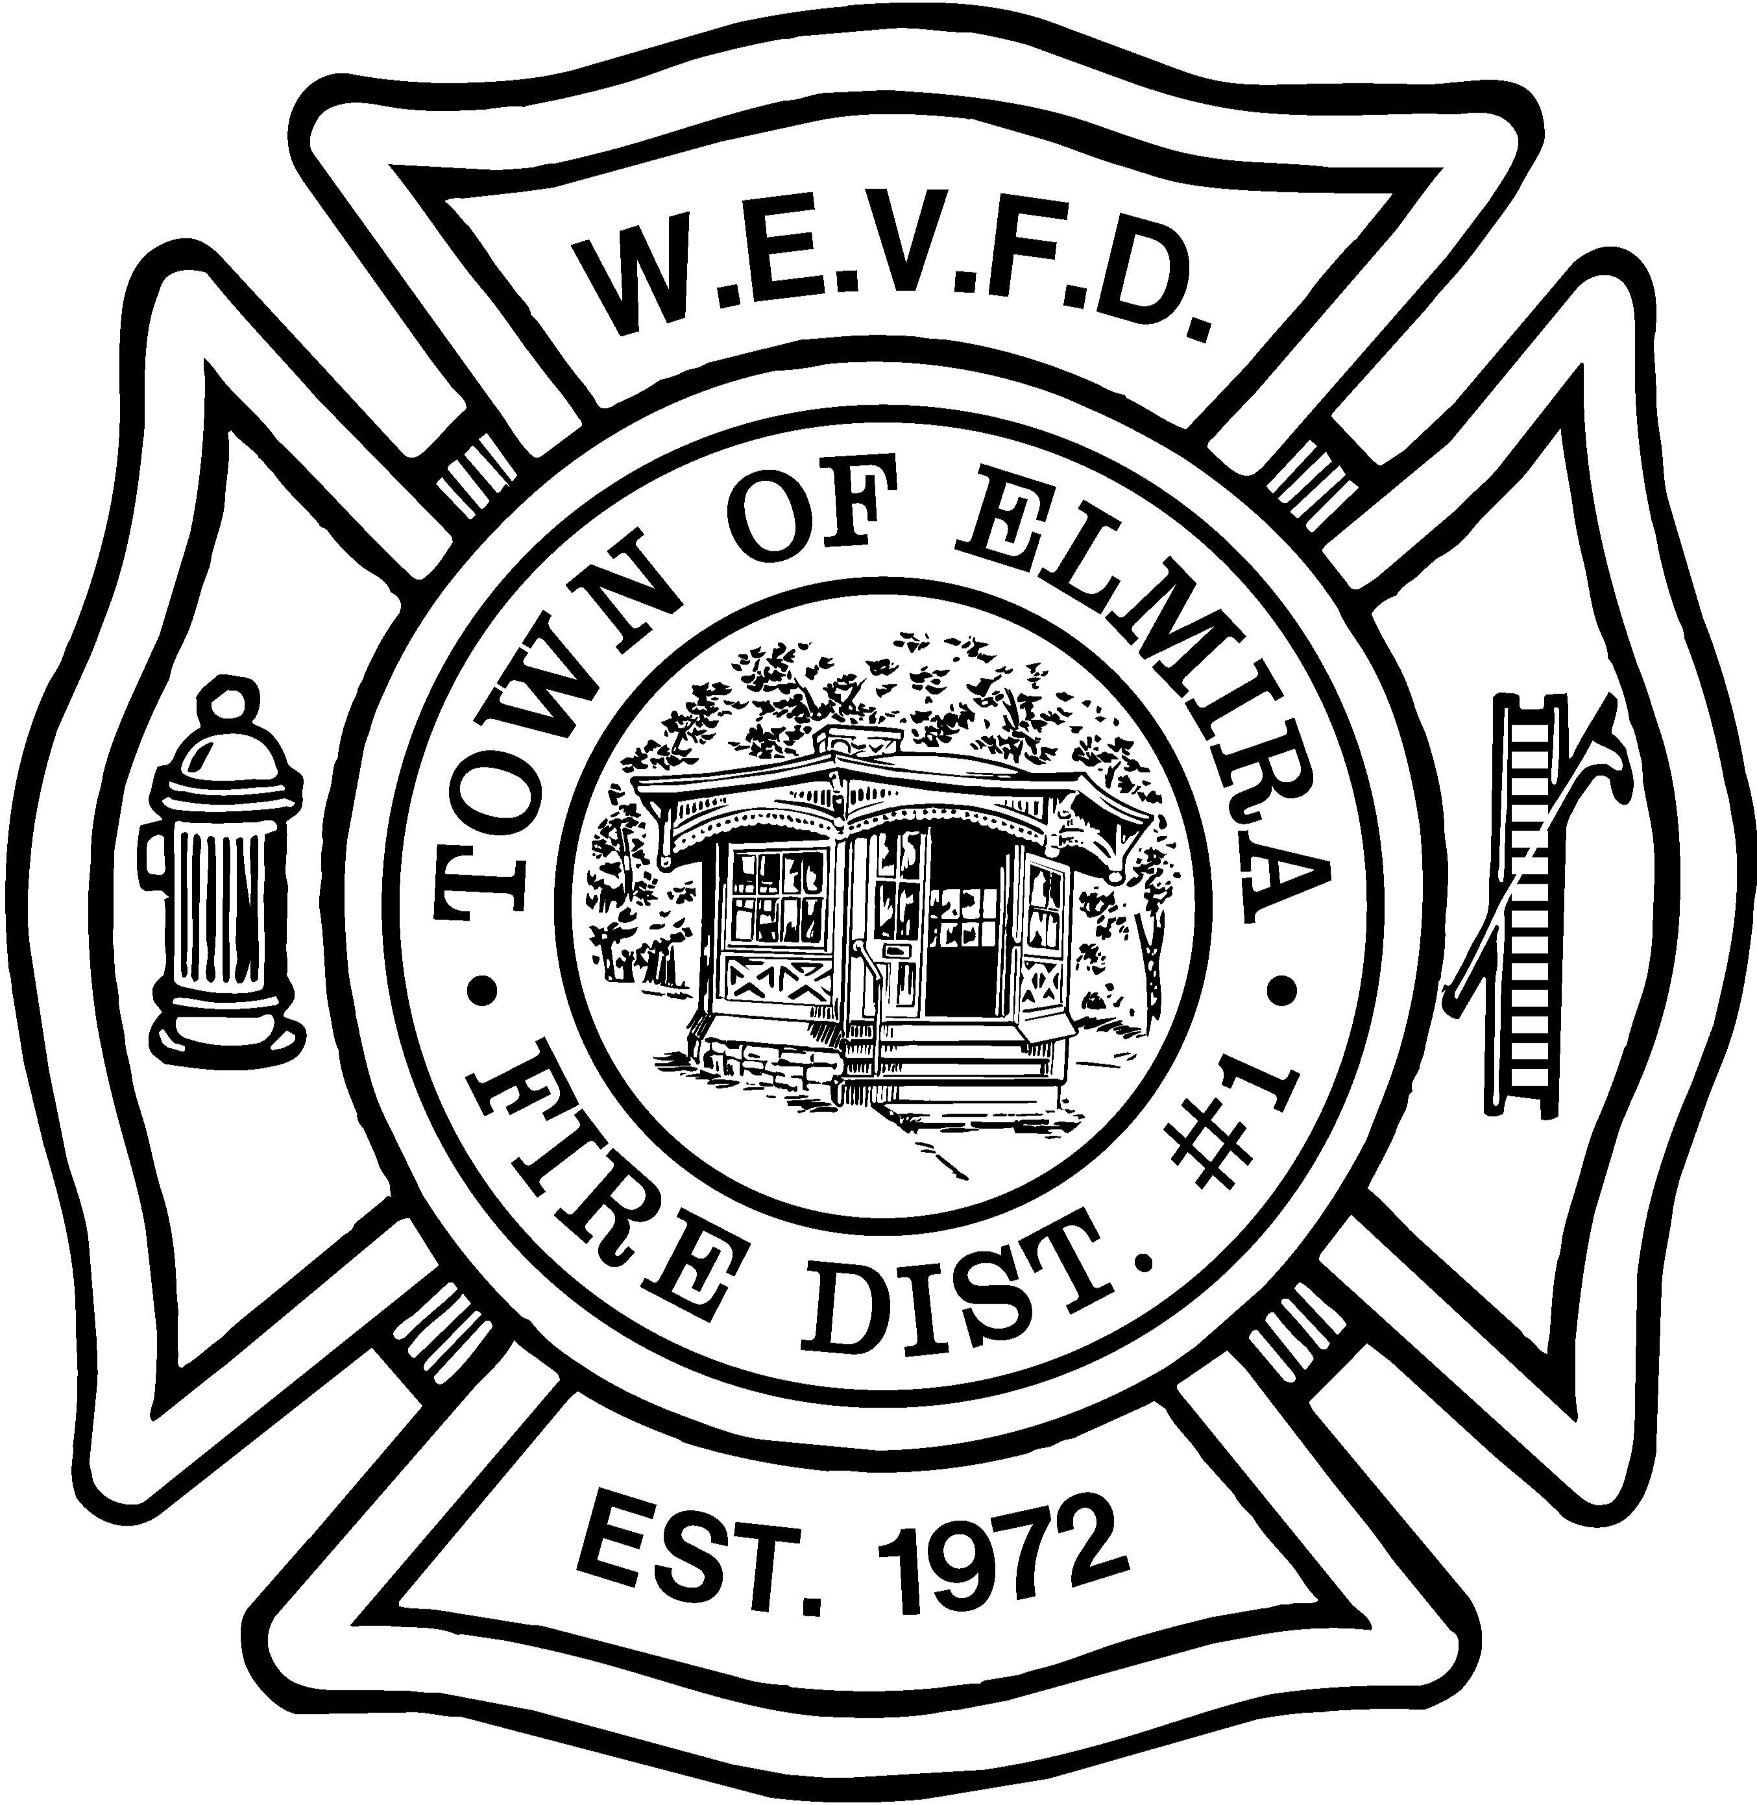

Member Handbook
2009

West Elmira Volunteer Fire Department

1299 West Water Street
Elmira New York 14905
607 734-2204

Member Handbook

Introduction

This handbook is intended to be a guide for new members to more quickly become familiar with the fire department, its structure and operations. It is intended as a general guide, and not a replacement for the department's Constitution and By-Laws or SOP’s (Standard Operating Procedures).

Please note that at any time the general membership, the Board of Directors, or the Fire Chief may suggest new policies for consideration. Every effort will be made to keep this book updated as needed.

Organization

The West Elmira Volunteer Fire Department, Inc. is a corporation that contracts with the Fire District No. 1, Town of Elmira, to provide fire protection and rescue services to the residents of West Elmira.

Fire District

Fire District No, l, Town of Elmira, consists of “West Elmira” starting at the city line (Guinnip Ave.) and contains all property south and west of a straight line running from Fassett Road to the top of the hill in the Estates Dr. area, then west to the Town boundary.
The Fire District owns the fire headquarters, most of the furnishings in it, and most of the fire-fighting and rescue equipment. The purchasing and administration of Fire District affairs is done by fire Board of Fire Commissioners. Money to operate and purchase this equipment and facility is raised by a tax on real property which is collected at the same time as other town taxes.

Fire Commission

The Fire Commission is made up of publicly elected officials who appoint chief officers each year to facilitate the operation of the fire department. While chief officers are nominated by the general membership, they, as well as every member of the fire department, must be approved by the commission.

Corporation

General

The corporate side of the fire department consists of the Board of Directors, committees, and the general membership. Monthly meetings are held to conduct the regular business of the department, including the organization of events, social functions and fund raising. General membership meetings are held on the third Monday of each month. The Board of Directors regularly meets on the second Monday of each month at 9:00 P.M., following drill.

Committees

Each member is expected to serve actively on a minimum of one committee. Committees are appointed by the President. Each member is strongly urged to participate in more than one working committee.

Members are also expected to participate in all department fund raising events.

Elections

Elections for the Board and other officers takes place the first Thursday, following the first Tuesday in April. Active and inactive members in good standing are eligible to vote. Inactive members may not vote for the nomination of chief officers.

Fire Activity Organization

The fire-fighting side of the department consists of the Chief, Line Officers, Career Firefighters (Paid Drivers), Firemen, and Fire Police.

Each and every active member of the fire department must attend training and meet performance requirements for specified activities.

Officers

The fire-fighting Line Officers are as follows:

Chief
Assistant Chiefs (2)
Captains
Lieutenants
Paid Driver / Dispatchers

The Driver/Dispatcher is in charge of the fire station and the fire scene, in the absence of a ranking officer.

At medical emergency calls, the ranking fire officer is in charge of the scene and the ranking medical officer is in charge of the patient.

Elections

Elections for corporate officers takes place the first Thursday, following the first Tuesday, in April. Active and inactive members in good standing are eligible to vote.

The Chief is nominated for a two-year term, while the Assistant Chiefs are nominated for one-year terms. These nominations are submitted to the Fire Commission for approval and appointment. The chiefs are primarily responsible to the Fire Commission.

Captains and Lieutenants are appointed by the Chief and must meet guidelines set forth in the department by-laws.

Membership
Equal Opportunity

Every resident of, or person employed in, the Fire District is eligible to join. The department does not discriminate against women or minorities, and encourages members to recruit applicants. Members must be 16 years or older, and must be in good health. Applicants must be approved by the department membership, the Fire Commission, and must pass a physical examination administered by a doctor of medicine, at the department's expense.

Privileges

Active members attend training, respond to calls, and are eligible for all programs sponsored by the department. Active members in good standing may vote and may attend the annual banquet.

The department has a company of fire policemen who are responsible for traffic control and security at all fires and emergencies, and have “peace officer” status. These members must complete NYS training and be registered with NYS/DCJ.

There is a provision in the department By-Laws to allow special active members such as ministers and physicians who volunteer their services to the department. These member are not required to attend drills or respond to calls, but are afforded privileges as active members.

Problems and Complaints

All members are encouraged to bring their complaints or problems to the attention of a Line Officer or directly to the Chief. If the matter has to do with the corporation it should be brought to the attention of the President or Vice-President directly.

Injuries

Any injuries sustained at the fire station, a training drill, or emergency scene or other department function should be reported to an officer immediately. All volunteer members are protected by the Volunteer Firemen's Benefit Law, which includes Fireman’s Compensation and death benefits.

Members with medical problems should bring them to the attention of the Chief at the earliest opportunity. These members may be reassigned until such time a physician releases them to full duty.

Public Access

While a private corporation, due to the nature of its business, the department is governed by the Freedom of Information laws. All meetings, with the exception of those specified in the laws, are open to the public.

Basic Training
Training

It is required that all new members complete the New York State Firefighter I, and/or Scene Support. These classes may be offered at another fire department. While attending class it is not necessary to attend regular department drills.

Regular Training Drills

The department conducts training drills each Monday (except for the third Monday of each month) and Tuesday mornings for those who work Monday evenings. Drills are not conducted on Federal holidays.

Attendance

Each member is expected to attend most drills and training sessions, for the department to comply with applicable state and federal regulations
.
Members will be assigned to specific trucks for training purposes, but will be expected to know the layout and operation of all department vehicle

State Classes

New York State offers a series of training courses. which are conducted at local fire departments.

Department members may attend classes at the State Fire Academy in Montour Falls, NY. On occasion these classes are held at other facilities. These classes are usually held on weekends and must be authorized by the Chief.

College credit is available for certain fire department courses.

EMS (Emergency Medical Services)

All members are encouraged to maintain a current CPR training certificate. Members are encouraged to become certified as First Responders or Emergency Medical Technicians. These classes are held at the EMSTAR facility, or local hospitals.

Fires and Emergencies

Response

Each member is expected to respond to all fire calls by reporting to the scene or to the station. Members with specialized training may also be required to respond to medical emergencies.

Response in Personal Vehicles

Members should respond directly to calls on their side of the station, and to the station for calls on the other side. ( For example, members living east of Hendy Ave. respond directly to calls east of Hendy, or to the station for calls west of Hendy Ave., and vice versa.)

When responding to calls, members are required to obey all speed limits and other traffic laws. Members will not be issued `blue light' cards. Those with prior authorization must use lights that conform to NYS Vehicle Laws and remember that they are for identification purposes only, and do not require other drivers to yield to the firemen. Those who have cards must carry them in their vehicle at all times.

Upon arriving at the scene each member should put on their protective gear and report to an officer for instructions. If no officer is available, go to a pumper and wait for assignment.

Parking

Upon arriving at the scene, vehicles should be parked on the same side of the road as the emergency vehicles to leave enough room for the passage of other emergency vehicles. Personal vehicles should be parked far enough before or after the scene to allow easy movement of the emergency vehicles and for safe traffic flow and control. Keys should be left in the vehicle in case it needs to be moved by emergency personnel.

Dispatcher

The fire station must be manned by a qualified firefighter/driver/EMT at all times.

Responding in a Department Vehicle

Only members 21 or older, and certified by the Chief or training officer, may drive an engine or aerial truck. Any licensed driver, 21 or older, may drive 2371, 2381, and 2382. Fire police will usually respond with 2371 and necessary traffic control equipment.

Upon arriving at the station, members should put on their full protective gear and man the equipment that will be responding after the first vehicle.

On all engines and the aerial, the driver and all passengers must be in seats and belted in. At no time is anyone to be standing anywhere on the vehicle, or sitting in an unapproved location. Members responding in the back of 2381 do not need to be belted in.

Protective Clothing

Full protective gear is required to be worn properly by each member, including officers, at an emergency scene. Members are required not to run, and to conduct themselves in a safe manner at all times. If you have damaged gear, report it to an officer immediately for replacement.

Air Packs – SCBA (Self Contained Breathing Apparatus)

Whenever entering a hazardous atmosphere, air packs must be worn at all times. Besides all burning buildings, this includes working on ladders outside burning buildings; at car fires, and in buildings even after fires have been extinguished.
Equipment

If you use a piece of equipment, you must make sure that is returned to the truck where it belongs or to the designated drop area. If necessary, you must make sure that the item is cleaned and undergoes proper maintenance back at the station before it is returned to service.

Valuables

Whenever finding valuables at fires or emergency calls, immediately request the presence of a police officer, or the Fire Officer in charge, and be sure that another department member witnesses your handling of the items. Be sure you know the person to whom you give valuables.

Entering Buildings

Only members who have completed NYS Basic and Intermediate Fire Fighting and Mask Confidence courses, and have received the authorization of the Chief, may enter burning buildings.

ID badges/number tags must be deposited at the Engine, and at the designated place any time you enter a building.

At no time may any member under the age of 18 enter a burning building or emergency scene.

Completion of Calls

After each call each member must return to the fire station to help prepare the trucks and equipment for the next call. Only after all trucks have been placed back in service is the call over. This decision will be made by the ranking officer.

After each call and training session, members must sign the dispatch sheet or record book. The book will be available only after all equipment is back in service.

Confidentiality

By the nature of our business we may learn about the personal lives of the residents of our Fire District. We consider ourselves to be professionals in the same sense as doctors and lawyers, and we respect the privacy of our residents. At no time should calls be discussed with anyone outside the department, with the exception of representatives of other involved agencies, such as the police and ambulance services.

Media

The department recognizes the responsibility of the media to inform, the public of our activities.
The Chief, or other designated officer, is the only spokesman for the department. He will meet with the media when convenient, and will issue a written press release for the media at the scene or calling the station. Only this information may be released to the members of the media.
Members of the media may move about the fire scene as long as they do not interfere with the work of the department, or endanger themselves or others. Other limits on members of the media may be set by a chief officer.

Media members visiting the station should be asked to wait in the TV room until the Chief is available. At no time is anyone, including members of the media, allowed to roam freely throughout the building during or after a fire/emergency call.

Standing Orders

Standing orders are for typical situations, but may be altered by an officer due to special circumstance, or situations.

Medical Emergencies

Rescue 2382 will respond. Only those members authorized by the Chief should respond directly to the emergency. Other members are to respond to the station.

Fires (within the district)

Engine 2331 will respond directly to the scene. Engine 2332 will respond next, to supply water, then Rescue 2382, and Aerial 2341 last. Truck 2371 will respond as required. All members should respond according to their point of origin. The exception is for a reported chimney fire when Aerial 2341 should be the first to respond, then equipment in the order above.

MVAs (motor vehicle accidents)

Rescue 2382, then Engine 2331. All members should respond to the station. except those authorized by the Chief to respond directly to a motor vehicle accident..

Car Fires (within the district)

Engine 2331, then Rescue 2382. All members should respond to the station or to the scene depending on their point of origin.

Mutual Aid (fires)

Engine 2332 with a crew of five (5), who are interior firefighters, including the driver and a fire policeman. All members should respond to the station. No member should respond directly to a scene in another fire district unless by special request of the host company.

Mutual Aid (Jaws of Life)

The department is fortunate to possess a Jaws of Life rescue tool owned by Chemung County. Neighboring departments may call for this tool at any time. Three members trained in the use of the tool will respond with it in 2382, as needed. Other members respond to the station.

Boat Rescues

Rescue 2371 with the boat on trailer. Only members who have passed a department swimming test and water rescue skills annually may enter the boat. Other members may respond to the station.

House Rules

Staffing

The fire station is manned 24 hours per day, every day. There is always at least one paid driver/dispatcher on duty, except for Saturday nights, when line officers work a shift on a rotating schedule.
Members may stay overnight on Saturdays to learn dispatch procedures.
Smoking
Smoking is prohibited in all areas of the building.
Alcoholic Beverages

Alcoholic beverages are strictly prohibited in the dispatch office at all times.

Alcoholic beverages are allowed in the building only with the specific authorization of the Board. If you are impaired by the consumption of alcohol or medication, you must not respond to calls. At no time before all equipment is back in service may alcoholic beverages be consumed at the station. At no time should a member consume alcohol beverages at the scene. Officers and driver /dispatchers are prohibited from consuming alcoholic beverages for 8 hours before a scheduled shift.

No person under the age of 21 will be permitted to consume alcoholic beverages.

Food and Beverages

Food and beverages are prohibited in any office or computer area.

Parking

Parking is strictly prohibited on the ramp in front of the bay doors, or on the street in front of the ramp. The exception is for Chief’s vehicles or police vehicles displaying emergency lights. Ramp parking alongside the driveway is reserved for department Fire Officers whose timely presence at the fire hall or fire scene is most important. In all cases, keys MUST be left in vehicles parked on the ramp in case they must be moved quickly.

Bulletin Boards

The bulletin board in the foyer is where all announcements, sign-up sheets, and other important items will be posted. Members should check the bulletin board each time they visit the station to keep abreast of current activities, policies and changes.

Department Equipment

Certain department equipment may be borrowed by members with proper authorization and sign-out Some items are prohibited from being removed from the building

Universal Gym

Members, their families, members of the auxiliary, and police officers may use the Universal Gym and other fitness equipment. Everyone who uses the gym must sign in and out with the driver on duty. Fitness equipment may not be used between the hours of 11:00 P.M. and 6:30 A.M.

Driver/Dispatchers

The fire station is available for the use and enjoyment of members. Members should realize that a driver/dispatcher is required to be in the building. For that reason they should be afforded reasonable courtesies by all members.

The driver dispatcher is not a janitor. Each member should clean up after themselves.

The driver/dispatcher is in charge of the dispatch office and the building and its contents while on duty.

Dispatch Office

In the event of a call, the dispatcher on duty may restrict entry to the dispatch office to department officers only. Members with pagers should turn them off before entering the dispatch office to prevent radio interference and feed-back. Members should not interfere with the dispatcher's ability to hear the radio by talking in the dispatch office.

Meeting Room
Each member is afforded the privilege of using the meeting room for private parties and functions. These must be applied for in writing and approved by the Board of Directors at its regular meeting prior to the requested date of use. A meeting room request form is available at the fire station.

Members who sponsor functions are expected to be in attendance from set-up to clean-up. The sponsoring member may designate another member to be in attendance if necessary.

Members using the meeting room for their own personal functions are not required to make a donation for use of the facility. However, the sponsoring member is responsible for cleaning the meeting room and kitchen after such use. If the member is sponsoring a function for someone else, a donation for use of the meeting room is required.

Donation

Anyone using the meeting room, including members. who generates garbage, is expected to make a minimum donation to cover the cost of its removal.

The professional drivers are not janitors. Cleaning service is available for a fee it you choose not to clean the meeting room after your function or event. (This is part of the agreement).

Catering

The WEVFD Ladies Auxiliary has the right of first refusal for the catering of events held in the meeting room, in advance of outside commercial caterers.

Plasma TV

The big screen television was purchased as a training tool for the department. It is not for entertainment and may not be used without the permission of the Chief.

Computers – Photo Copiers

There are numerous computers and photo copiers at the fire station. These have been purchased for record keeping, report preparation and training purposes only. The department computers and copiers are to be used only for department purposes. Only members may use this equipment and only with the express permission of the Chief or the Board.

Activities
Conventions and Travel

The department authorizes delegates to attend certain meetings and conventions each year, and the Chief authorizes members to attend training sessions out of town.

The department will reimburse expenses for travel, meals, and registration fees for the member only (the cost of a companion accompanying the member will be at the expense of the member, not the Department). The member’s anticipated expenses must be authorized in advance by the Chief or the board of directors.

The Board of Directors will set mileage reimbursement rates and per diem rates for meals and lodging. (Note: If you are being reimbursed for such expenses you will not be able to claim them on your tax returns). It is expected that members should travel in groups to reduce travel expenses whenever possible.

Detailed original receipts documenting all expenditures must be provided before receiving reimbursement.

Ladies Auxiliary

There is a Ladies Auxiliary that supports the activities of the department. The wife, daughter, or mother of an active member is eligible to join. Membership in the organization is voluntary.

The auxiliary meets the second Tuesday of each month at the fire station.

Parades

Occasionally the department participates in parades. Participation is voluntary.

Sports

Occasionally the department participates in softball leagues, bowling tournaments, and
hose team competitions. Participation is voluntary.

Sexual Harassment Policy
Purpose: Explanation of Sexual Harassment and the obligation of the West Elmira Volunteer Fire Department, Inc..

Statement:

- Both the Equal Employment Opportunity Commission (EEOC) and the New York State Division of Human Rights considers Sexual Harassment a violation of law prohibiting discrimination based on sex. The EEOC issued guidelines, effective November 10, 1980, regarding sexual harassment in the workplace

2. The guidelines define sexual harassment as unwelcome sexual advances, requests for sexual favors, and other verbal or physical conduct of a sexual nature. The guidelines state that such conduct is illegal sexual harassment when:

A. Submission is made a term or condition of employment, or
B. Submission or rejection of such conduct is used as the basis for employment decisions, or
C. Such conduct has the purpose or effect of unreasonably interfering with an individual's work performance, or creating an intimidating, hostile or offensive working environment.

- The West Elmira Volunteer Fire Department will not knowingly allow sexual harassment of its employees or members by Officers of the Department or the Corporation, co-employees, members or non-members in the workplace. Any employee who engages in sexual harassment will be subject to discipline, up to and including discharge; and any member or non-member may be denied access to the Fire Department or its facilities.

Procedure:

1. Any employee or member who feels they have been subjected to sexual harassment is strongly encouraged to report this issue to the Chief. An alternative reporting route may be used, preferably the personnel Chief, or the Board of Directors' Personnel Committee. In this issue it is more important that the employee reports to any member of the above management entities, than it is to observe "normal" reporting routines and protocols.

2. The member of management receiving the report is advised to contact the Board of Directors Personnel Committee without delay. The committee will respond as follows:

A. Investigate the report. This may involve obtaining further details from the employee or member and visiting with other employees and/or members if this seems advisable or appropriate to gain a complete understanding of events.

B. The Personnel Committee will assemble all relevant details available and determine whether further action is appropriate, and what that action should be.

C. When the Personnel Committee has concluded its investigation and determined whether the situation will call for corrective action, the employee or member reporting the problem will be advised. While it may be prudent to hold some details in confidence, the personnel committee will convey the essence of its conclusions. For example: "Your reports have been confirmed and the other employee or member has been counseled appropriately". The employee/member is strongly urged to keep the Chief and/or Personnel Committee informed of the impact of its corrective actions. The employee's freedom from harassment is paramount, and is to be assured regardless of any other action planned.

D. Finally, the employee or member is to be assured that the honest reporting of the problem will not produce any negative impact on the employee's or member's status. The employee or member should immediately notify the personnel committee should the employee or member continue to experience a problem with harassment, or it becomes evident that the corrective measures have been ineffective.

