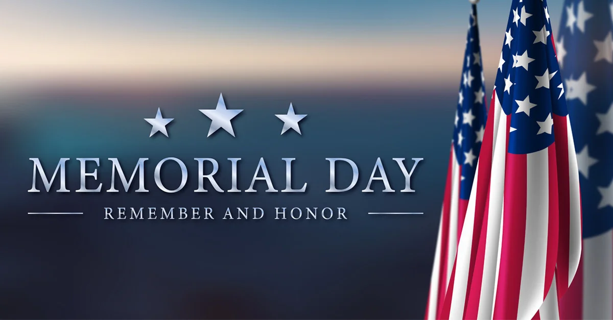
Forest Lawn Memorial Park
563 Jerusalem Hill Rd, Elmira, NY 14901
(607)734-6696

You are cordially invited to attend a ceremony to honor our fallen May 29th at 7:30am

